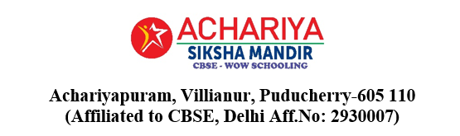

Benchmarking / Best Practices

Benchmarking enables our school to systematically compare its academic and co-curricular performance with other reputed CBSE institutions as well as with internal standards.

This process fosters a culture of continuous improvement and supports the enhancement of student performance, teaching quality, and co-scholastic achievements. Through benchmarking, our school can identify strengths, address areas requiring development, and ensure progressive educational outcomes.

Power Teaching Method:

Power Teaching is an interactive, high-energy instructional approach designed to actively engage students throughout the lesson. It uses techniques such as gestures, call-and-response, repetition, and peer teaching to improve understanding and retention. This method encourages collaboration, maintains student attention, and makes learning more enjoyable and effective.

Practice Example:
After the teacher explains a concept, students repeat it to their partners using actions and keywords (“Teach–Okay” method).

Benefit:
Increases student attention, participation, and retention.

  - Students are fully engaged using voice + movement
  - Learning becomes fun and memorable
  - Peer interactions improve understanding and confidence

Teaching Methodologies Practiced to Develop Student Skills

Our school adopts a variety of effective and interactive teaching methodologies to ensure holistic student development, promote critical thinking, and enhance real-life application of concepts.

List of Teaching Methodologies:

- Demonstration Method
- Activity-Based Learning (ABL)
- Project-Based Learning (PBL)
- Experiential Learning
- Collaborative Learning
- Power Teaching Method
- Gamified / Game-Based Learning
- Circle Method
- Discussion / Socratic Method
- Concept Mapping / Flowchart Method
- Mind Mapping
- Role Play / Simulation Method
- Differentiation Method
- Peer Teaching / Group Discussion
- Storytelling Method
- Hands-on Learning Approach
- Brainstorming Method
- Visual, Auditory, and Kinesthetic (VAK) Method
- ICT-Enabled Teaching (Smart Boards, Digital Labs)
- Questioning Method
- Model-Based Teaching
- Formula Substitution Method
- Learning Through Examples / Bullet Points
- Jolly Box Method
- Real-Life Correlation Method
- Board Test Method

Link : https://youtu.be/AweAlTc05OQ?si=KYzfjf4y6v_ackWH

Flipped Learning

Flipped Learning is an instructional approach where students learn new concepts at home through videos, online lessons, or reading materials, and then use classroom time to apply their learning through discussions, problem-solving, and hands-on activities. This method supports deeper understanding, collaboration, and personalized teacher guidance during class

Practice Example:
Before a science topic, students watch a short video; in class, they perform an experiment or project based on it.

Benefit:
Encourages self-learning, responsibility, and deeper understanding.

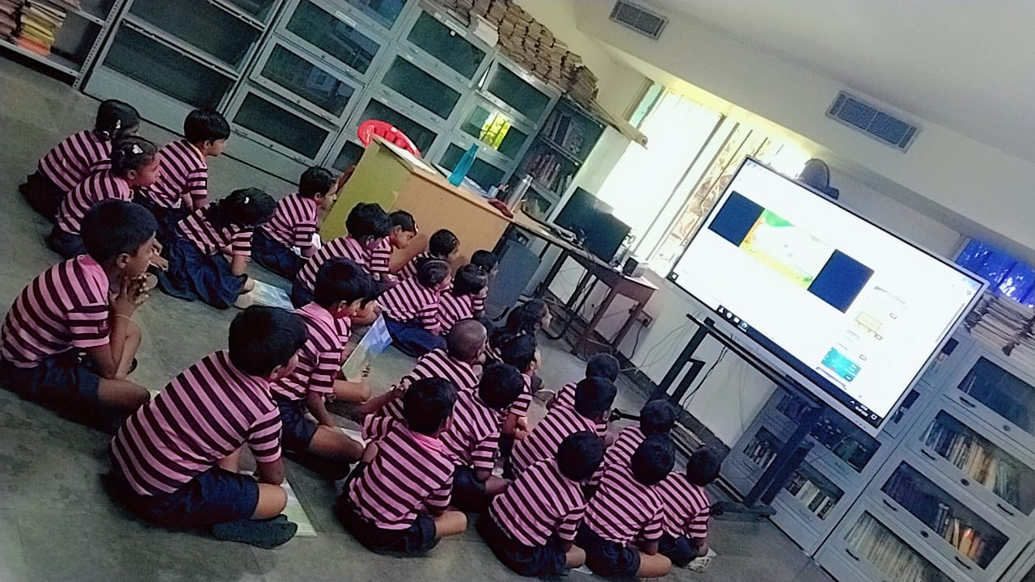

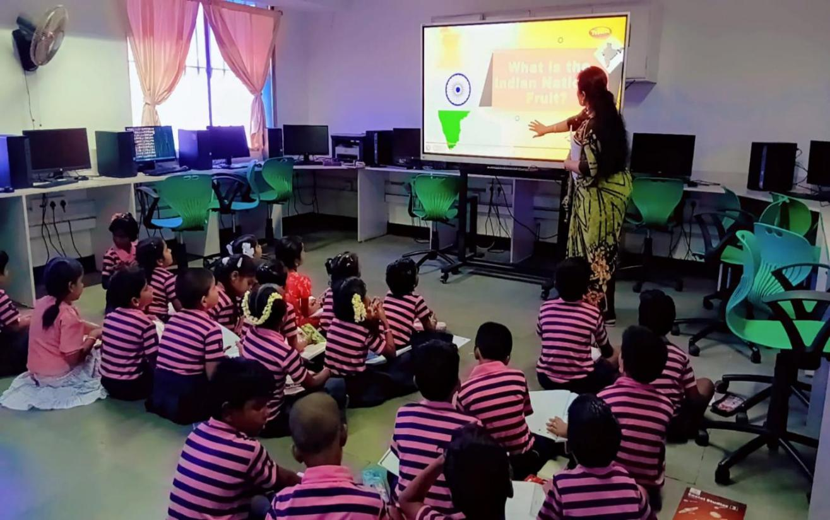

  - Students come prepared with background knowledge
  - Classroom becomes more interactive and collaborative
  - Teacher can give personalized attention to students who need help
  - Higher-order thinking skills are practiced during class

Spiral Learning

Spiral Learning is a progressive teaching approach in which key concepts are introduced at a basic level first, and then revisited over time with increasing depth and complexity. This ensures improved understanding, long-term retention, and mastery as students connect new learning with what they already know.

Practice Example:

Topics like “Water Cycle” in Science are first introduced with basic facts in lower grades and revisited in higher grades with advanced applications.

Example – Science (Water Cycle)

Grade Level | Concept Taught | How Complexity Increases
Class 3 | Basic water cycle – evaporation, condensation, rain | Simple diagram + naming processes
Class 5 | Full cycle – evaporation, condensation, precipitation, collection | Causes, examples, real-life impact
Class 7 | Detailed processes and human influence | Groundwater, transpiration, pollution, conservation measures

Benefit:

Enhances long-term understanding, retention, and critical thinking among students.

Experiential Learning
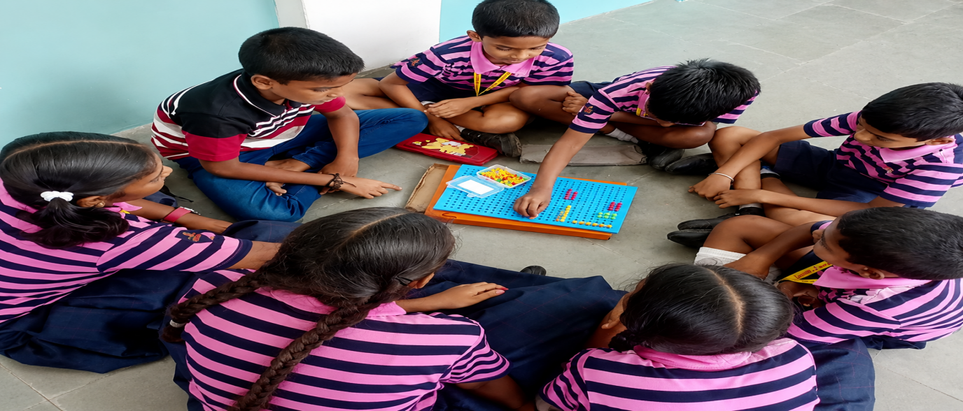
- Collaborative Learning

Parallel Processing

Parallel Processing is a learning approach where students think, connect, and process information from multiple perspectives at the same time. It encourages simultaneous engagement of creative, analytical, verbal, and physical skills, improving focus, coordination, and cognitive flexibility.

Practice Example:
Students analyze a story for its moral values (English), historical background (History), and artistic presentation (Art) - and present it through parallel processing activities such as Silambam (traditional martial art), Skipping routines, or solving the Rubik’s Cube while narrating or explaining concepts.
This integrated practice enhances both mental agility and motor coordination.

Benefit:
Encourages multi-dimensional learning, improves concentration and memory, and develops the ability to synchronize mental and physical skills, preparing students for complex, real-world problem-solving.

- Enhances memory retention by activating multiple senses at once
- Improves concentration and coordination during learning tasks
- Strengthens cognitive flexibility and quick decision-making
- Encourages active participation and deeper understanding

Link: https://www.youtube.com/watch?v=QLK4VDaGN0Y



Ambidexterity (Writing in both the hands)

Ambidexterity involves training students to write and perform tasks using both hands, which helps balance analytical (left-brain) and creative (right-brain) skills. This practice enhances brain coordination, improves handwriting agility, and supports stronger neural development in learning.

Example – Ambidexterity Activity (Classroom)

During a handwriting session:

Students write simple letters, numbers, or short words using their non-dominant hand

  - They also perform mirror writing or draw basic shapes with both hands simultaneously
  - Gradually progress to writing short sentences or copying notes with both hands This engages both left and right hemispheres of the brain at the same time.

Benefit:
Promotes flexible, balanced, and well-rounded learners.

  - Strengthens brain connectivity and cognitive development
  - Improves fine motor skills, handwriting control, and visual-motor coordination

Enhances focus, creativity, and problem-solving abilities
  - Builds confidence by helping students master new learning skills

Link: https://youtu.be/QqfPHnV1vSQ?si=xB97dSA5ZH1g8uf_

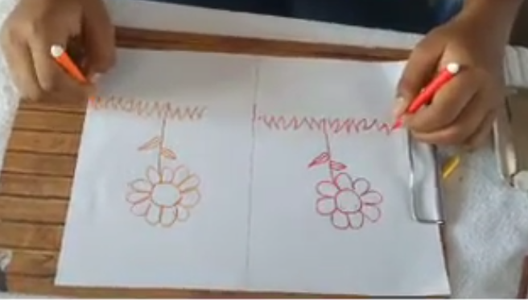

WOW Schooling

WOW Schooling is a joyful and child-centered approach that creates a happy and caring learning environment. It emphasizes motherhood-like care, strong parent–teacher bonding, and continuous encouragement for students in all activities. This approach nurtures confidence, emotional well-being, and holistic development in every child.

Practice Example:
Incorporating mindfulness sessions, outdoor exploration into daily learning.

During the activities,

- Students participate in joyful, hands-on activities like art, music, storytelling, and games
- Teachers give warm, caring interactions—appreciating each child personally
- Parents are invited to join to support through activities
- Every child’s effort is celebrated with stars, smiley cards, or applause

This creates a happy school atmosphere where children feel loved, supported, and excited to
learn.

Benefit:
Builds emotional balance, curiosity, and a love for learning.

- Promotes emotional security and happiness in students
- Builds positive relationships between teachers, parents, and children
- Increases student participation, confidence, and motivation
- Encourages holistic development in academics and life skills
- Reduces stress, anxiety, and absenteeism
- Supports a safe, caring, and joyful school culture

Link: https://youtu.be/3iiz6ql6wWo?si=KheOeB1ncFIavJDW

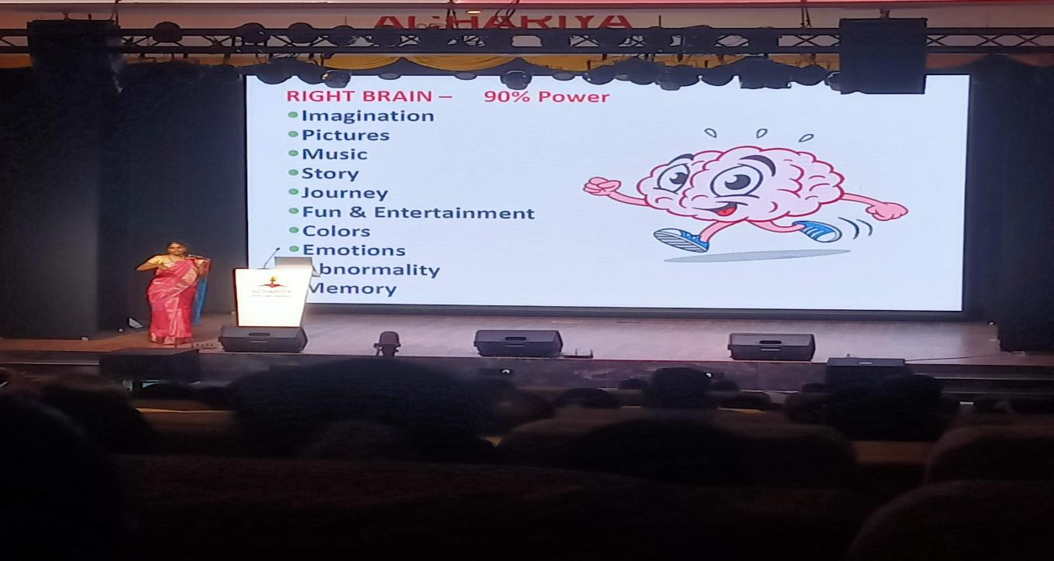

Study Techniques

Study Techniques involve guiding students to develop effective study habits, time management skills, and organized learning strategies. This helps them plan their work, revise better, stay focused, and take responsibility for their learning, leading to improved academic performance and confidence.

Practice Example:
Use of mind maps, memory techniques, link and story method , acronym method, PMS method, etc.

Benefit:
Improves concentration, organization, and academic performance.

  - Improves time management and reduces last-minute stress
  - Strengthens memory, focus, and understanding
  - Develops self-discipline and responsibility for learning
  - Helps students perform better in assessments
  - Builds confidence and lifelong learning skills

Link: https://youtu.be/vFn5EuTfNnE?si=-fB9LILljSzoPRl1

21st Century Skills
21st Century Skills prepare students to succeed in the modern world by developing Critical Thinking, Communication, Collaboration, Creativity, and Digital Literacy. These skills enable learners to solve problems, work effectively with others, express ideas confidently, and use technology responsibly for learning and innovation.

Practice Example:
Group discussions, ICT-based projects, and peer collaborations.

Benefit:
Prepares students for real-world problem-solving and teamwork.

  - Enhances problem-solving abilities
  - Strengthens teamwork and leadership skills
  - Improves communication and presentation confidence
  - Encourages innovation and creativity
  - Prepares students for future careers and real-life challenges
  - Builds responsible and tech-savvy learners

Link: https://youtu.be/jfSwP1cfzcE?si=aH0PBCYFYpkZPZY8

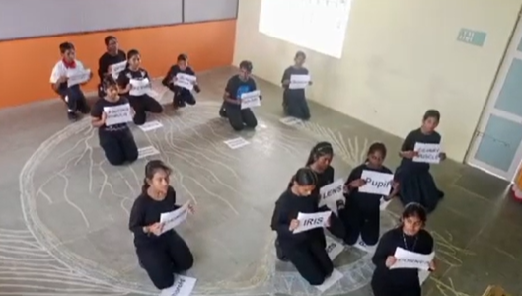

Guru Poornima Day

Guru Poornima Day is a special celebration dedicated to honoring teachers and mentors for their guidance, knowledge, and support. Students express their gratitude and respect through , thank-you cards, sweets and meaningful gestures that strengthen the teacher-student relationship.

Practice Example:

On Guru Poornima Day, students highlight the importance of teachers and mentors by expressing gratitude for their guidance and wisdom. They present handmade cards and thoughtful gifts as tokens of appreciation. Teachers also share motivational messages that inspire students to uphold values such as discipline, respect, and lifelong learning. This celebration strengthens emotional bonding and nurtures a culture of respect within the school community.

Benefit:

Instills respect, gratitude, and cultural values among students.

  - Encourages gratitude, respect, and value for teachers

Strengthens teacher–student and parent–teacher relationships
  - Builds students’ moral values and cultural awareness
  - Enhances confidence through public speaking and cultural participation
  - Creates a positive school climate with emotional bonding

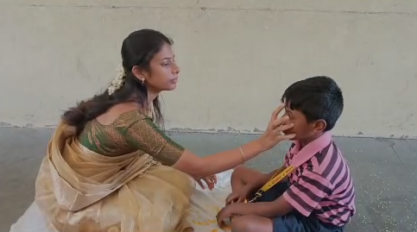

Link: https://youtu.be/jfSwP1cfzcE?si=aH0PBCYFYpkZPZY8

ASTRA

ASTRA is an Olympiad-based program designed to enhance Mathematics and Science skills among students. It nurtures gifted and talented learners by providing advanced concepts, competitive exposure, and challenges beyond the regular curriculum. This initiative promotes logical reasoning, problem-solving, and higher-order thinking abilities.

Practice Example:
Higher-level Olympiad training, and mentorship.

  - Students attend special coaching sessions for Olympiad topics in Math and Science
  - High-achieving students receive mentor guidance and enrichment materials
  - Participation in inter-school and national level Olympiads boosts confidence and exposure

This enables students to explore advanced concepts and perform beyond grade-level expectations.

Benefit:
Encourages innovation, leadership, and excellence.

Strengthens logical reasoning, analytical and critical thinking
  - Identifies and nurtures gifted and talented students
  - Builds competitive spirit and academic excellence
  - Enhances performance in future higher competitive exams
  - Motivates students to pursue STEM learning pathways

Olympiads - NSO, IMO, IEO, IGKO, ISSO, IHO, ICSO

Olympiads are competitive examinations that assess students’ logical reasoning, analytical skills, and subject proficiency in areas such as Science, Mathematics, English, General Knowledge, Social Studies, Hindi, and Computer Science. Participation in these exams encourages higher-order thinking and motivates students to excel beyond classroom learning

Practice Example:
Participation in Science, Math, English, Social, Hindi, GK, Computer Science

  - Students enroll in Olympiads like NSO (Science), IMO (Maths), IEO (English), IGKO (General Knowledge), ISSO (Social Studies), IHO (Hindi), ICSO (Computer Science)

  - The school conducts Olympiads exams
  - Top achievers are recognized through certificates, medals, and awards
  - Students gain national & international exposure through ranking and results

This boosts student motivation and academic competitiveness.

Benefit:
Boosts academic confidence and sharpens competitive skills.

Enhances analytical thinking, problem-solving, and reasoning skills
  - Improves conceptual clarity and academic excellence
  - Builds confidence for future competitive exams
  - Encourages self-assessment and independent learning
  - Provides opportunities for national-level recognition

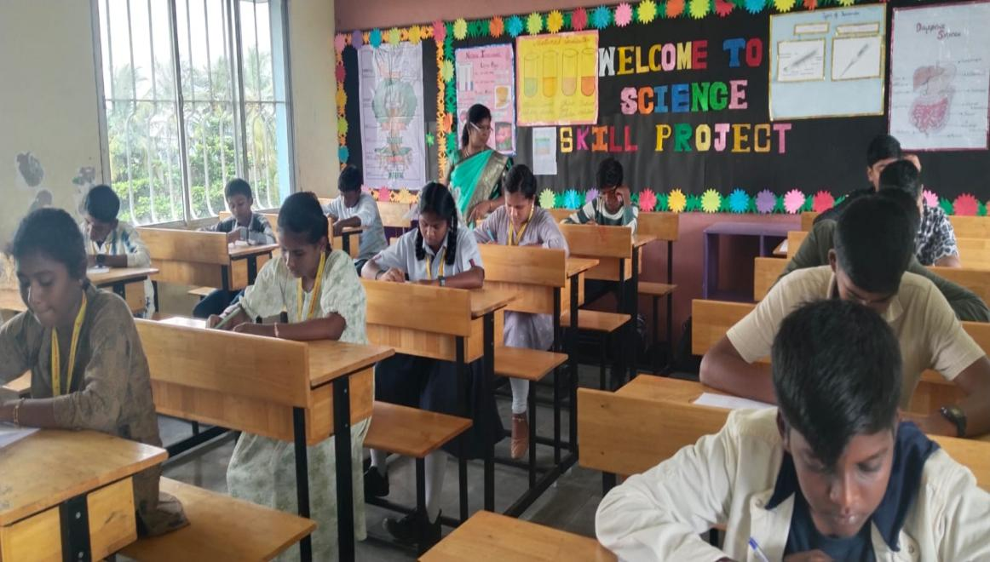

Link: https://drive.google.com/drive/folders/1Y2KenEcMhviStjtcd0GctkuX_SVblSec?usp=drive_link

BMIT (Brain Mapping Intelligence Test)

BMIT is a diagnostic assessment designed to identify each student’s learning style, aptitude, strengths, and type of intelligence. By understanding how students learn best, teachers can provide personalized support, helping them achieve greater success through tailored teaching strategies.

Practice Example:
Students take the BMIT annually; teachers use results to plan differentiated lessons.

BMIT in School Practice:

  - Students take the Brain Mapping Intelligence Test to assess their dominant learning style (Visual / Auditory / Kinesthetic) and multiple intelligence areas
  - Teachers receive individual BMIT reports for each student
  - Based on the results, teachers adapt teaching strategies like using more visuals, hands-on activities, or discussions
  - Students are encouraged to build on their strengths while improving weaker areas

This ensures personalized and effective learning support.

Benefit:
Personalized teaching and better academic outcomes.

  - Helps teachers understand how each student learns best
  - Improves student confidence and performance through targeted support

Enhances teacher-student and parent-teacher collaboration
  - Supports early identification of talent, interests & abilities
  - Encourages holistic growth by balancing strengths and challenges
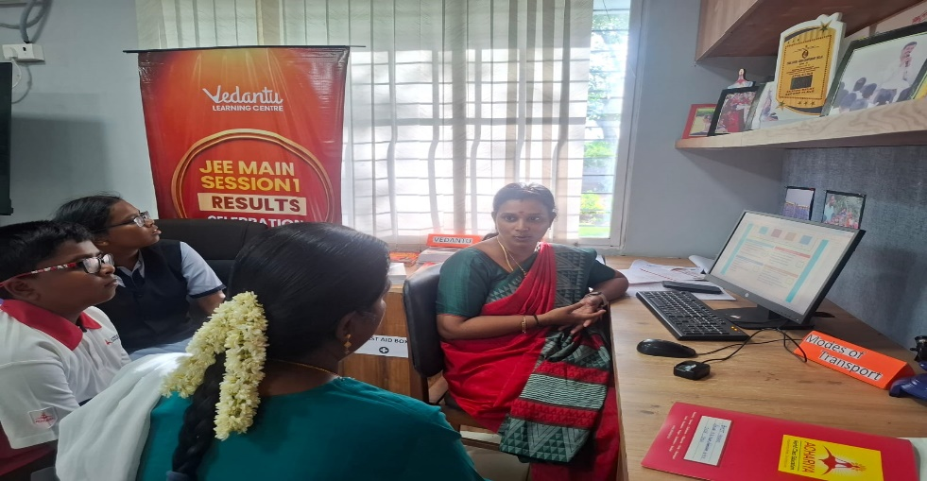

Meditation

A daily mind-calming meditation practice is scheduled from 12:00 pm to 12:10 pm in our school to help students relax, improve focus, and develop emotional balance. This short break in the day refreshes the mind, reduces stress, and promotes inner peace supporting better learning and behavior.

Practice Example:
10 minutes guided meditation after 12pm- 12.10pm daily.
Every day at 12:00 pm, the school bell rings for a 10-minute meditation break:

- Students sit quietly with eyes closed and practice deep breathing
- A teacher or audio guide leads mindfulness and relaxation
- Calm music or silence helps students de-stress and reset
- After meditation, classes resume with improved focus and positivity

This simple routine supports students’ mental well-being throughout the school day.

Benefit:

Improves concentration, memory, and learning efficiency
- Reduces anxiety, anger, and restlessness
- Enhances self-control and emotional management

Promotes discipline, patience, and calm behavior
- Boosts overall mental health and happiness in school

Link: https://youtu.be/AMYG8gEi0uw?si=-rhM0Xku1wMfNHFR



Daily Morning Routine

Our school follows a structured daily morning routine that includes Yoga, Brain Gym exercises, Thoppukaranam, and positive affirmations. This practice promotes discipline, physical fitness, mental alertness, and a positive mindset, ensuring students begin their day with energy, focus, and enthusiasm for learning.

Practice Example:
A structured start to the school day promotes discipline, positivity, and overall well-being among students. Each day begins with a series of mindful and physical activities that prepare learners for an active and focused school day.
Benefit:
  - Promotes discipline and mindfulness
  - Enhances concentration and academic performance
  - Builds physical fitness and flexibility
  - Reduces anxiety and boosts confidence
  - Creates a positive school environment

Link: https://drive.google.com/drive/folders/1eAn4f8PjOE6TgSvJKg_alKfc21_0x1bl?usp=drive_link

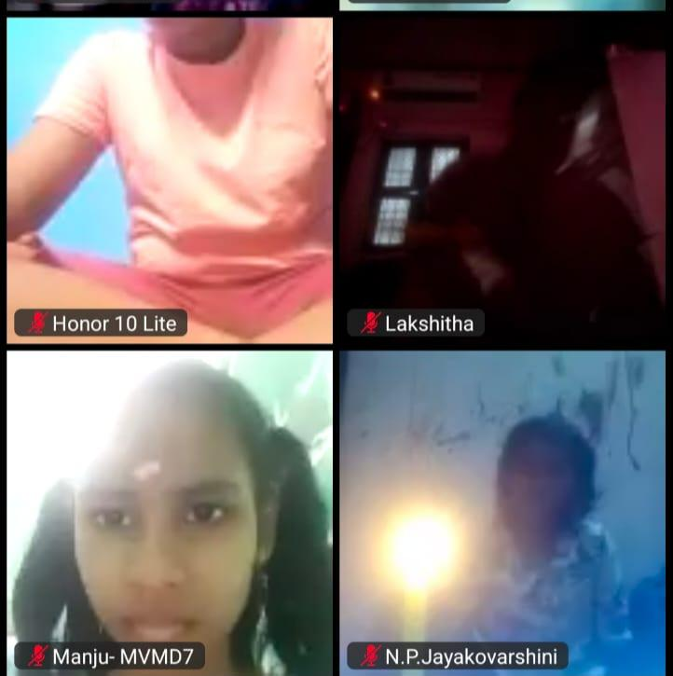

DivyaDrishti

A transformative program designed to develop intuition, sharp observation, creativity, and innovative thinking among students. It includes activities such as memory games, pattern recognition tasks, visualization practices, and sensory awareness techniques that stimulate the brain’s higher-order thinking skills.

By engaging both the left and right hemispheres of the brain, the program nurtures critical thinking, problem-solving ability, and imaginative thinking, helping students approach learning with curiosity and confidence.

Practice Example:

Students engage in color & picture identification, visual puzzles and creative problem-solving activities.

Benefit:

- improved concentration and decision-making
- Enhanced memory and mental agility
- Boost in creativity and innovation
- Better emotional awareness and confidence

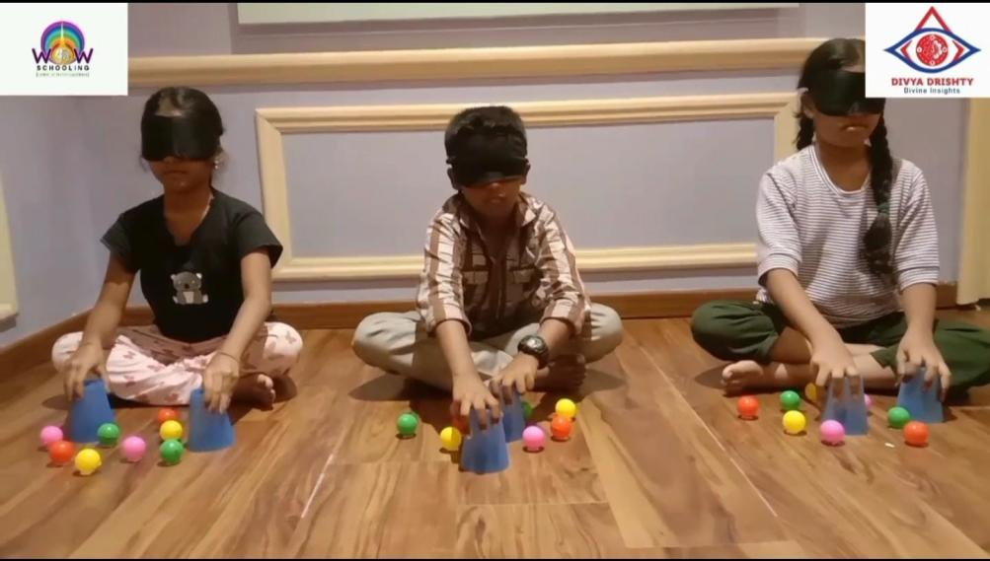
Link: https://youtu.be/T7ZPqNzx_JQ

Nap Time (DivyaNithra)

A short relaxation break scheduled daily from 12:40 pm to 12:50 pm to help students refresh their mind and body after lunch. During this time, students rest in a calm environment that promotes better concentration, reduced stress, and improved learning efficiency for the remaining school hours.

Practice Example:
10–15 minutes of quiet rest or guided relaxation.

Benefit:
- Refreshes the mind and enhances afternoon learning focus

Link: https://youtu.be/qycKLtxsRM4

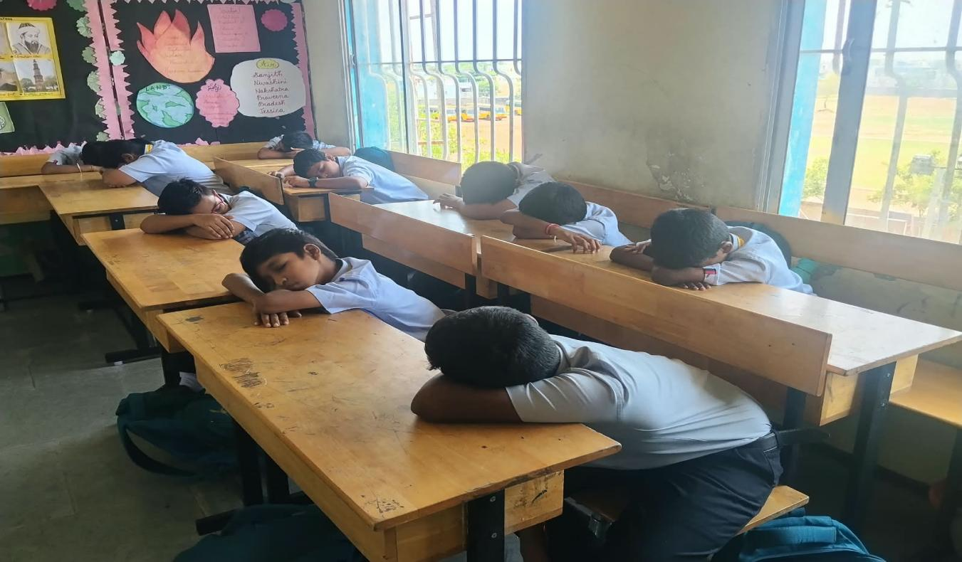

DivyaVidya

A spiral learning and value-based education approach where students are introduced to core concepts at lower grades, and these concepts are revisited, expanded, and integrated into advanced learning in higher grades. Along with academic growth, DivyaVidya ensures students develop strong values, life skills, and moral understanding as they progress through each level.

Practice Example:

DivyaVidya follows a spiral learning system. Students learn foundational concepts in lower grades, and the same ideas are revisited with deeper understanding in higher grades. Along with academics, DivyaVidya shapes character, values, discipline, empathy, and life skills.

Benefit:

  - Builds integrity, empathy, and a strong moral foundation.
  - Holistic growth
  - Emotional and social development
  - Strong value system
  - Better discipline and leadership qualities

Link: https://drive.google.com/file/d/1mr4RqDgfCZcdTaUZaLObWGaYoG4UgDiV/view?usp=drive_link

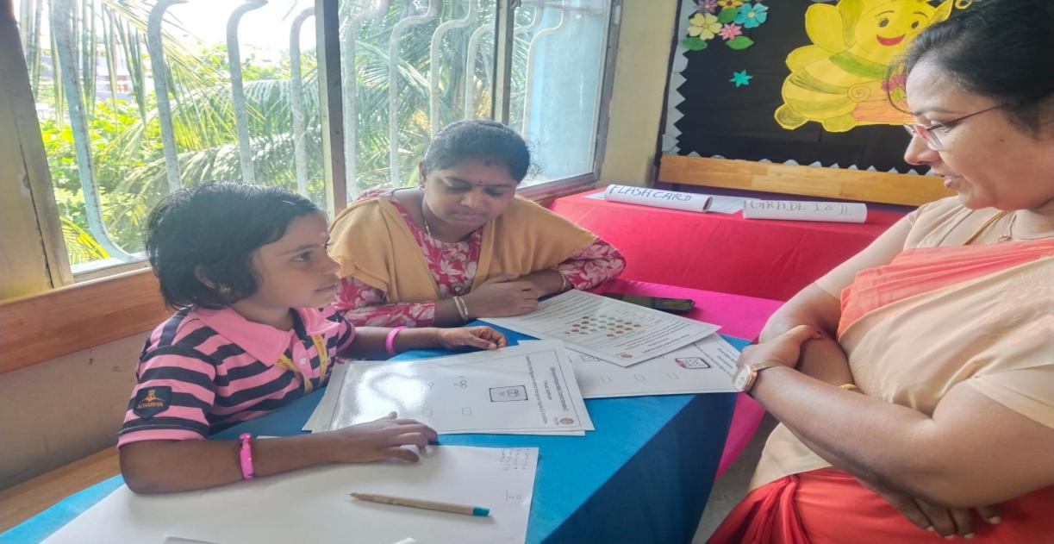

Classroom Library

A Classroom Library is a small reading space set up inside each classroom, stocked with age-appropriate books to promote a strong reading culture among students. It encourages self-reading, improves vocabulary, and nurtures a love for literature through easy access to books during free time and designated reading hours.

Practice Example:
Students borrow books weekly and share reviews.

Benefit:
- Improves vocabulary, comprehension, and imagination.

Link: https://youtu.be/KIchTHsrNYA

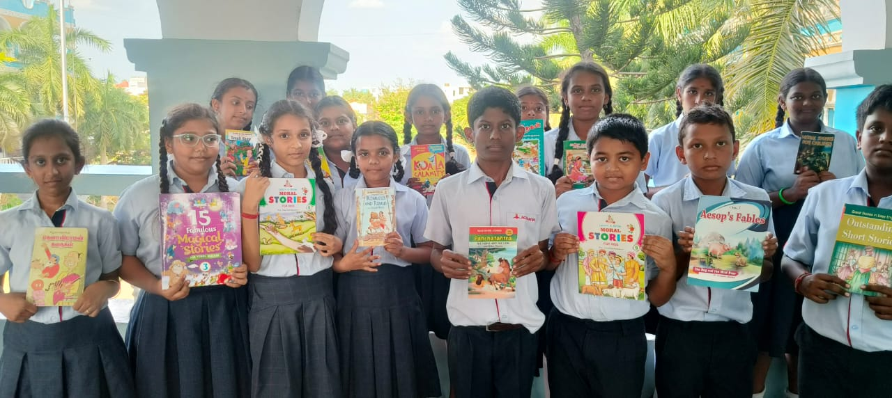

Action Sequence Board

An Action Sequence Board is a visual tool that displays a series of pictures related to a concept. Students observe the sequence and explain the concept as a story, helping them understand order, logic, and narration skills.
It also acts as a performance tracker, showing student participation and progress in communication, comprehension, and creativity.

Benefit:

Motivates students and builds a sense of accountability and achievement.

  - Enhances storytelling and speaking skills
  - Supports concept understanding through visuals

Improves logical thinking and sequencing ability
  - Encourages active participation and confidence

Link: https://youtu.be/pPEpE6EUeqo?si=JIYemulbdNrc6o9N

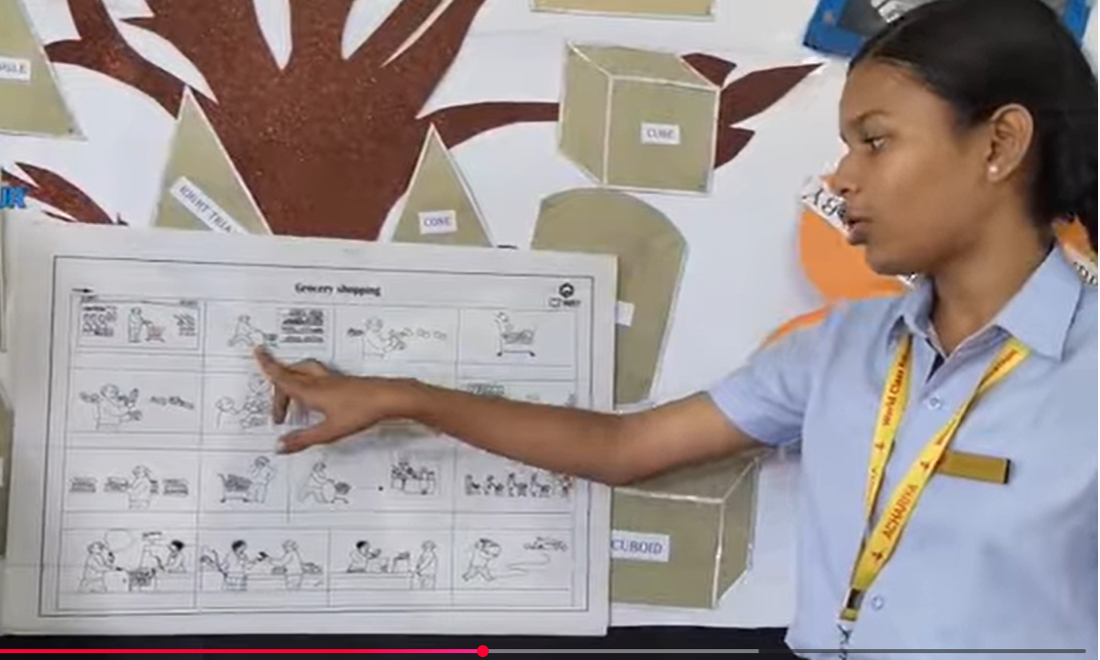

Ayangara style

Saptamahakriya:

Saptamahakriya is a wellness program designed to promote holistic development in students. It integrates Golden Smile Meditation where children focus on each of the five major organs - Lungs, Heart, Liver, Spleen, and Kidney - representing the elements of Saptamahakriya, along with their associated healing sounds, breathing exercises, and mindfulness practices.

This daily routine helps students:

  - Maintain a calm and focused mind
  - Develop positive emotions and self-awareness
  - Improve physical health and energy balance
  - Build emotional strength and confidence

Practice Example:

Students perform daily breathing, stretching, and meditation exercises during morning assembly.

Benefit:

Promotes emotional stability, focus, and physical well-being.

Oil Pulling

A traditional Ayurvedic oral health practice where oil is swished inside the mouth to remove toxins and harmful bacteria. It is included in the school’s wellness routine to promote better oral hygiene and overall health awareness among students.

Practice Example:

Students perform oil pulling under supervision once a week as part of the morning wellness routine. Teachers provide proper guidance on duration and method.

Benefit:
Improves oral hygiene, strengthens gums and teeth, reduces bad breath, and encourages students to adopt healthy traditional practices from a young age.

Link: https://drive.google.com/file/d/1rIILkSr_MWyyJdvPGy35KNrFuaiYbJ2v/view?usp=drive_link

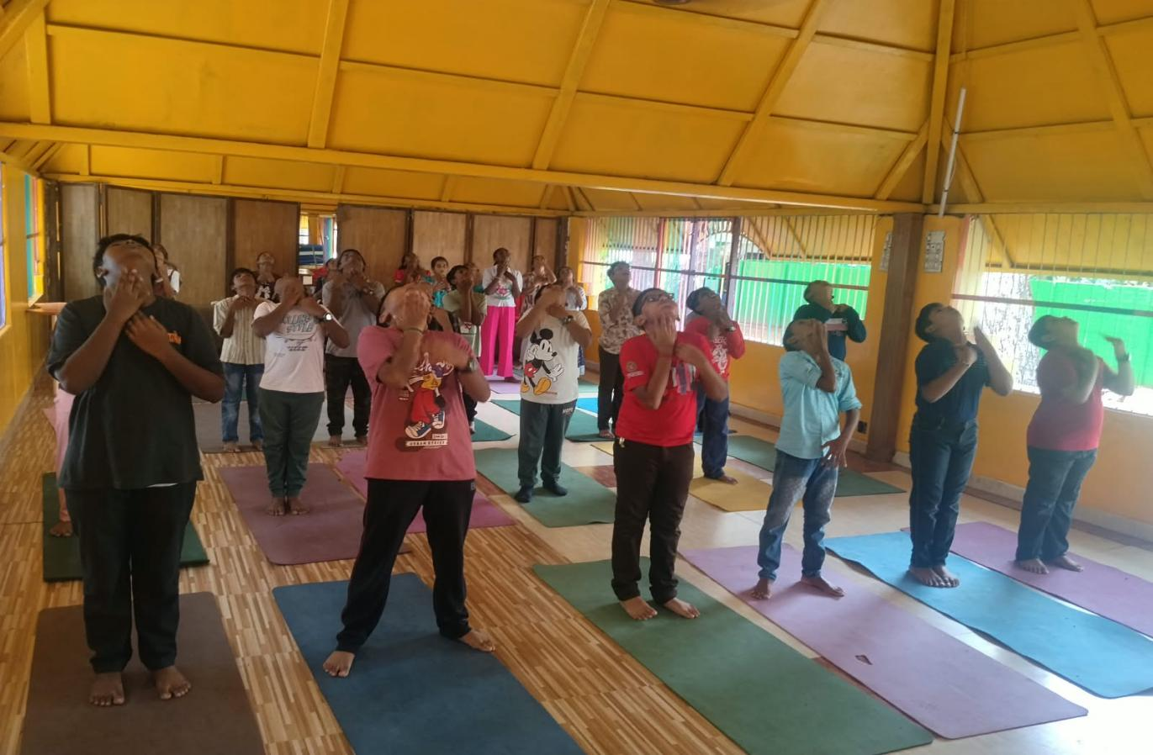

Lion Meeting (Department-wise with Teachers)

A structured review and planning session conducted department-wise where teachers evaluate their academic progress using the L-I-O-N format:

  - L – Last Week: Review of syllabus covered and activities completed
  - I – Issues: Challenges faced in teaching-learning or student understanding
  - O – Opportunities: Strategies and new methods to improve learning outcomes
  - N – Next Week: Planning lessons and targets for the upcoming week

Practice Example:
During weekly meetings, teachers present their planner and discuss portion coverage, classroom challenges, and student needs. Solutions are collaboratively planned—such as differentiated teaching or re-teaching activities—to ensure continuous improvement.

Benefit:
Promotes accountability, collaborative problem-solving, and effective academic planning. It ensures smooth syllabus progression, improved teaching quality, and timely support for students.

Link:https://drive.google.com/file/d/1vKUVIGP9tK5vLVAt76AJWYh0WlAZtGXC/view?usp=sharing
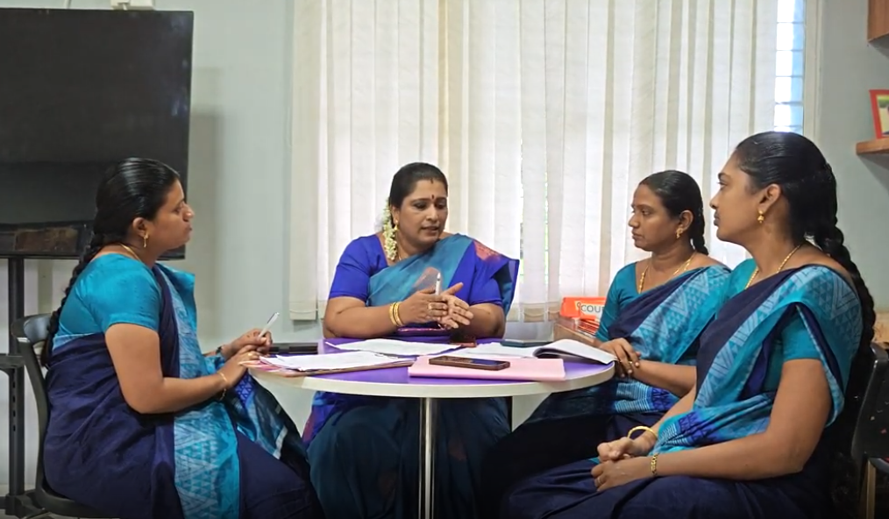

Reading Card

A reading progress tool designed to strengthen literacy skills and foster a strong reading culture among students. Each reading card encourages students to practice loud reading with correct pronunciation, actions, expressions, and emotions, followed by summarizing the story to ensure comprehension and communication development.

Practice Example:

Students select a reading card weekly and first practice reading aloud in class. They then progress through multiple stages—silent reading → reading with actions → reading with expressions
→ reading with expressions and emotions. Finally, they paraphrase or summarize the story/message in their own words and share their reflections with peers or the teacher.

Benefit:

Improves fluency, pronunciation, comprehension, expression, emotional connection to text, and confidence in communication. It nurtures a lifelong love for reading and enhances presentation skills.

Link: https://youtu.be/o78QD869U6c?si=5E_jad03jzgJtUSv

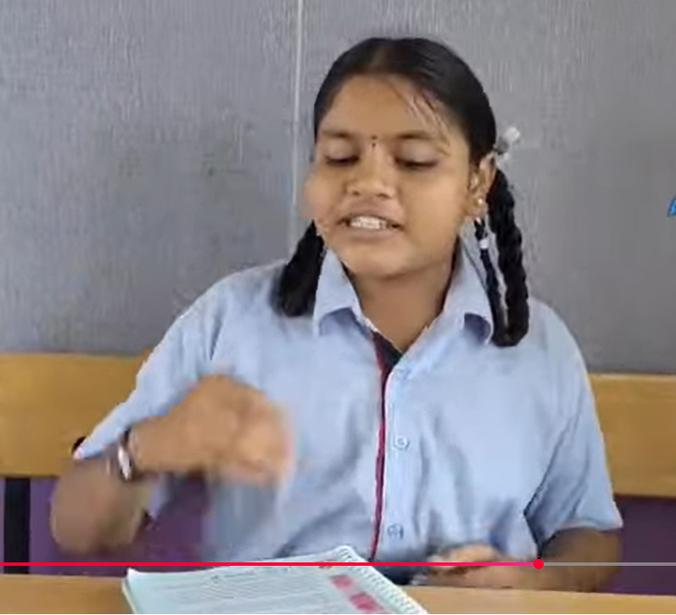

Super speed Card

A structured fluency-building tool that helps students improve their reading, writing, and mental arithmetic speed. Using a timer or stopwatch/stop clock, students practice reading passages at 1x, 2x, and 3x speed, promoting faster processing, accurate recall, and confident academic performance.

Practice Example:
Students complete weekly timed activities where they read passages, write sentences, or solve arithmetic problems at increasing speeds (1x → 2x → 3x). Their progress is recorded in the Superspeed Card, allowing them to track improvements over time.

Benefit:
Enhances speed, accuracy, concentration, and confidence in core academic skills. It strengthens quick thinking, reduces hesitation, and prepares students for effective performance in assessments and real-world tasks.

Link: https://youtu.be/o78QD869U6c?si=5E_jad03jzgJtUSv



Kreya (Grade 1 to 8)

[[
Kreya is a dedicated creative learning period where students explore design and innovation
through hands-on activities. They get opportunities to build and experiment with blocks, drones, and other creative tools, fostering problem-solving, critical thinking, and technical skills in a fun, engaging environment.

Practice Example:
Hands-on projects, displays, or model-making.

Benefit:
Develops creativity, innovation, and fine motor skills.

Link: https://youtu.be/eU_6axCt9VM?si=DG2UuKP9J2h_fygh

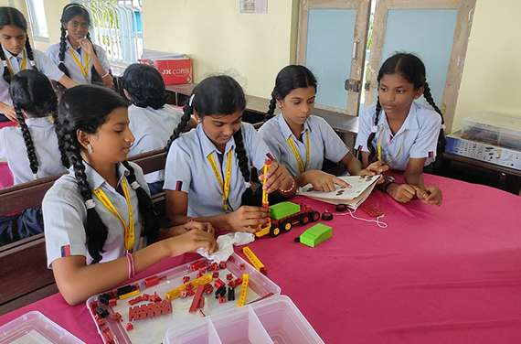

Parihara Statement

A Parihara Statement is a reflective or corrective note where a student acknowledges responsibility for their actions and commits to improvement. For example, if a student arrives late to school, they write/read a Parihara Statement to reflect on the behavior and plan steps to be punctual in the future.

Practice Example:
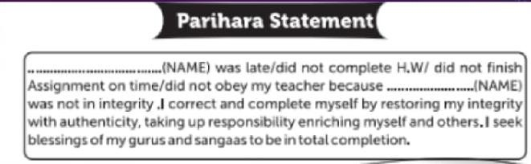

Benefit:
Encourages accountability and personal growth.
Link: https://drive.google.com/file/d/1pUbZanU7JY8teEOAYDn1zK6FVa7NlKVb/view?usp=drive_link

Habitometer

The Habitometer is a self-assessment tool that helps students track their daily habits and behaviors. Students record their progress in a diary, encouraging consistency, self-reflection, and personal growth in their routines.
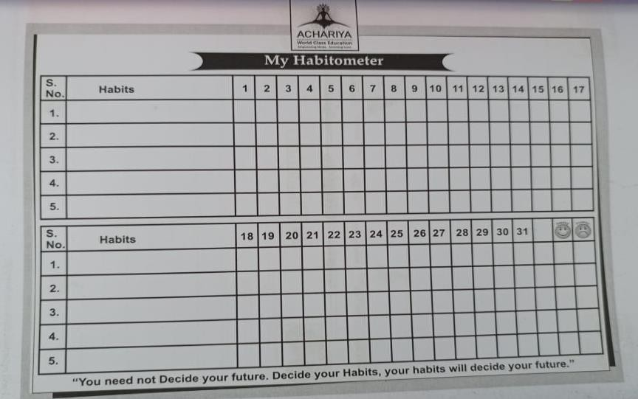

Practice Example:
Weekly self-rating on punctuality, respect, teamwork, and discipline.

Benefit:
Develops consistency and positive character traits.

Link: https://drive.google.com/file/d/19cQtWdPVXuL_ys3ctRIGt0zNZzdfpn2m/view?usp=drive_link

White Book

The White Book is a tool that helps students connect their inner circle with the outer world by exchanging visiting cards and initiating conversations. Students engage with family members, elders, and social service contributors, enhancing communication skills, social awareness, and confidence in interacting with diverse people.

Practice Example:
Includes reflections, communication, and conversation.

Benefit:
Helps track improvement and set goals.

Link: https://youtu.be/68VDLbxPXck?si=Px91IkHhmjAYk7Ub

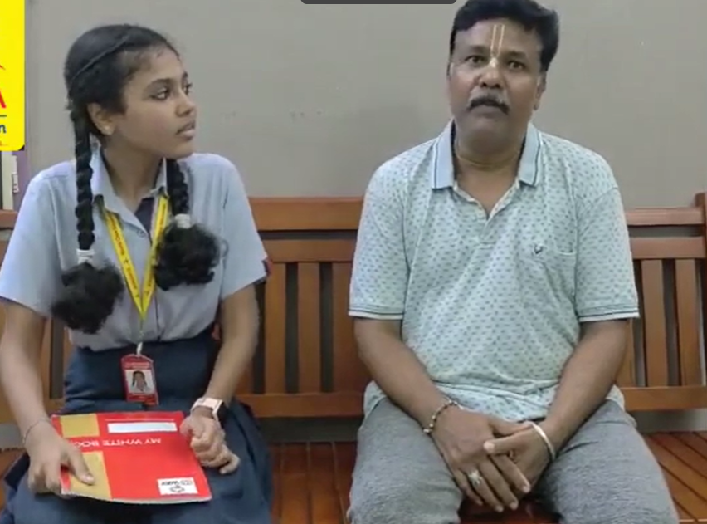

Yellow Book

The Yellow Book is a record where students reflect on 110 values they read and apply in daily life. It helps track personal growth, develop positive behavior, and cultivate values that guide them to lead a responsible and meaningful life.

Practice Example:
Entries include remarks, achievements, and reflection notes.

Benefit:
Promotes self-awareness and emotional intelligence.

Link: https://youtu.be/2rD-Z3Jp55k?si=qwyvcyj-69QX7QJH

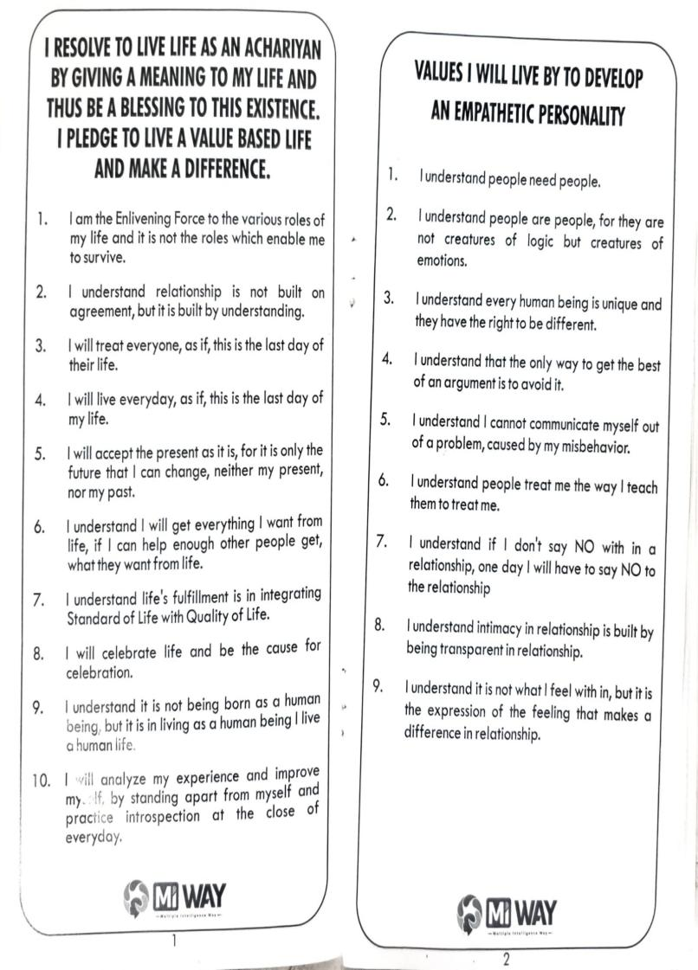
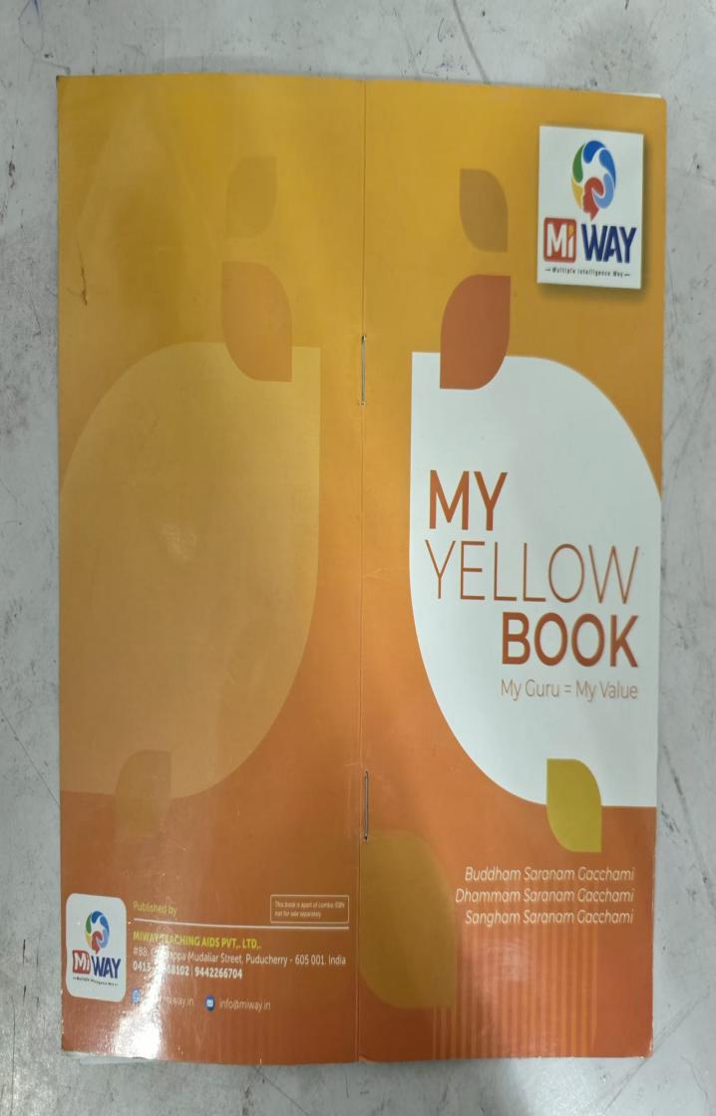

Green Book (Dream to Destiny)

The Green Book is a reflective journal that helps students set goals, monitor progress, and track personal growth, guiding them to turn their dreams into achievable outcomes.

Practice Example:
Students write their goals and achievements on progress.

Benefit:
Encourages self-awareness, goal-setting, and personal responsibility.

Link: https://youtu.be/3_IV-RF3Fko?si=ZNGBeM2PIMbz5Wj4



Citation Day
Citation Day is a special event where students are formally recognized for their achievements and excellence—academic, behavioral, or creative. Awards include Champion of Champions, General Proficiency, Star of the Year, Bumble Bee 5 Icons (Initiator, Influencer, Imaginator, Impact Creator, Innovator), and 100% Attendance. Each student also presents a speech on their ambitions and future goals, making it a memorable and inspiring moment.

Practice Example:
Award certificates during citation for achievements in internal and external competitions and academics.

Benefit:
Encourages motivation and excellence.

Link: https://youtu.be/Smvu-BFp0EI?si=cF_6e-ySnV11aYtf

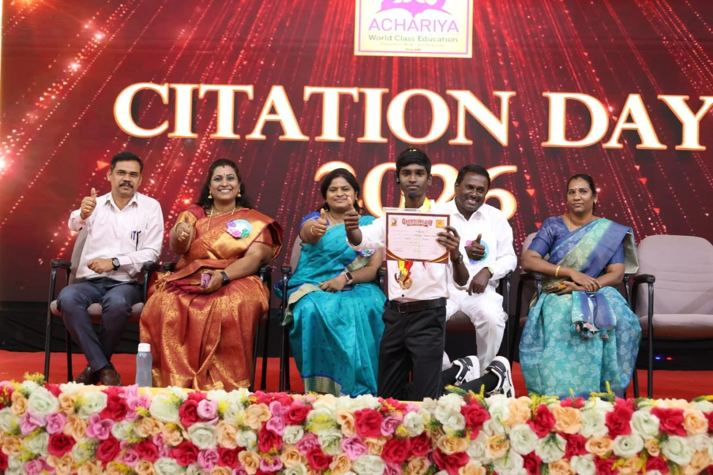

Skill Project

STANDS (Students’ Talent Ability New Discovery Session):
STANDS is a hands-on learning initiative where students demonstrate subject-wise concepts from the cumulative portions of each term. It connects academic knowledge with real-life skills, fostering creativity, problem-solving, and practical application of learning.

Benefit: Enhances critical thinking, problem-solving, and entrepreneurship.

Link: https://youtu.be/5oaEhNyVRow?si=bm58rmw-8tfzzVXf

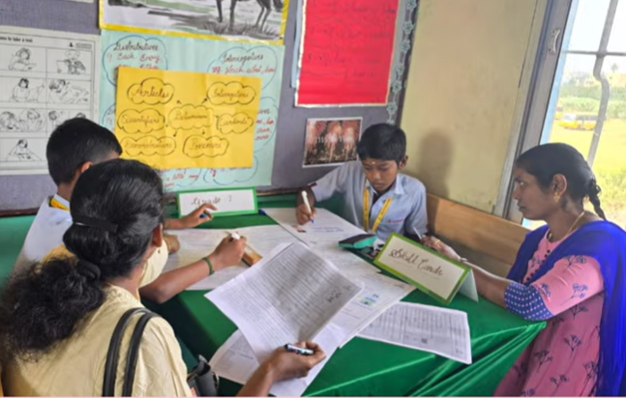

Sports

Sports are an essential part of holistic education, promoting physical fitness, teamwork, discipline, and a healthy competitive spirit among students.

Practice Example:

Weekly sports periods, inter-house tournaments, and activities such as bean bag games, juggling, and hula-hoop are conducted to encourage student participation.

Benefit:

Improves physical health, team spirit, and leadership qualities.

Link: https://youtu.be/4P-oSuiR9G8?si=W3gfeZOXhPgKI8O4

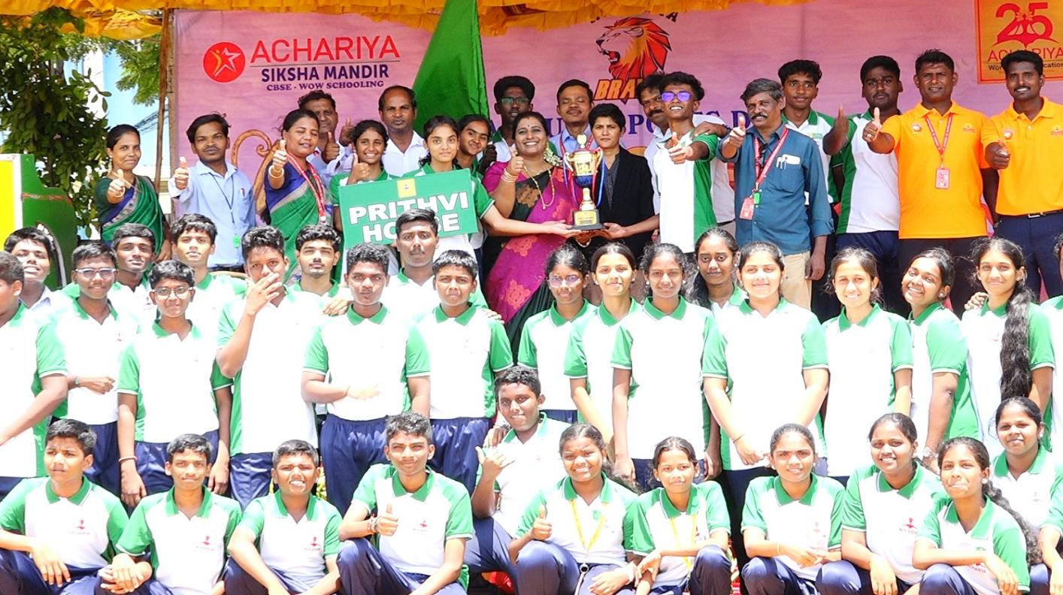

Spiritual Learners

Spiritual learning for teachers is very helpful for their personal and professional growth. Our school provides this opportunity by sharing positive thoughts and values that support their holistic development and well-being. These spiritual learning practices help teachers maintain a positive outlook, strengthen their character, and reflect on their life and work. In turn, inspired teachers are able to guide students effectively and contribute to their future progress and success.

Practice Examples:

  - Daily meditation or mindfulness sessions
  - Reflective journaling about personal and professional experiences
  - Sharing positive thoughts and values in staff meetings
  - Engaging in gratitude or affirmation exercises

Morning Reflection & Positive Thought Sharing:

Each day begins with a short reflection session where teachers engage in mindful breathing, listen to a motivational thought, or participate in a value-based discussion. This helps them start the day with calmness and clarity.

Benefits:

  - Enhances self-awareness and emotional well-being
  - Strengthens character and ethical decision-making
  - Promotes a positive outlook and reduces stress
  - Improves ability to guide and inspire students effectively

Supports holistic personal and professional growth
  - Teachers develop patience, empathy, and emotional balance, which positively influences classroom behavior.
  - Students observe and learn essential values such as respect, kindness, and responsibility.
  - A peaceful and supportive learning atmosphere is created, helping students stay focused and confident.
  - Teachers become better role models, encouraging students to set goals and develop a positive attitude toward life.

Link: https://drive.google.com/drive/folders/1KVYvtVG_Dylj6CvmOtfIy_d_9iWNRd-p?usp=drive_link
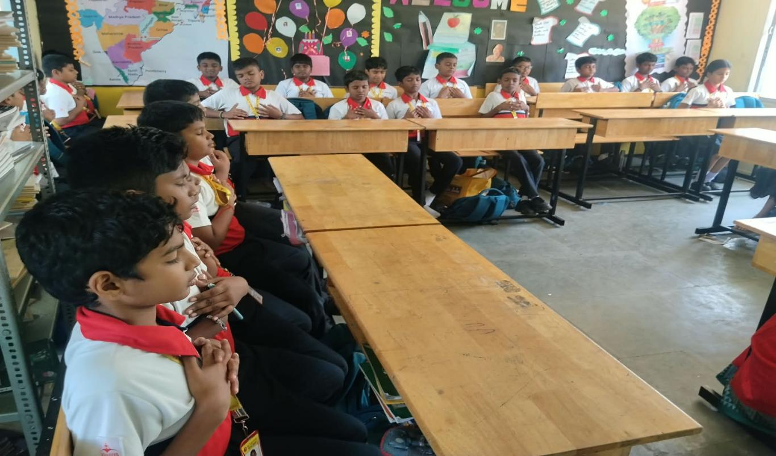

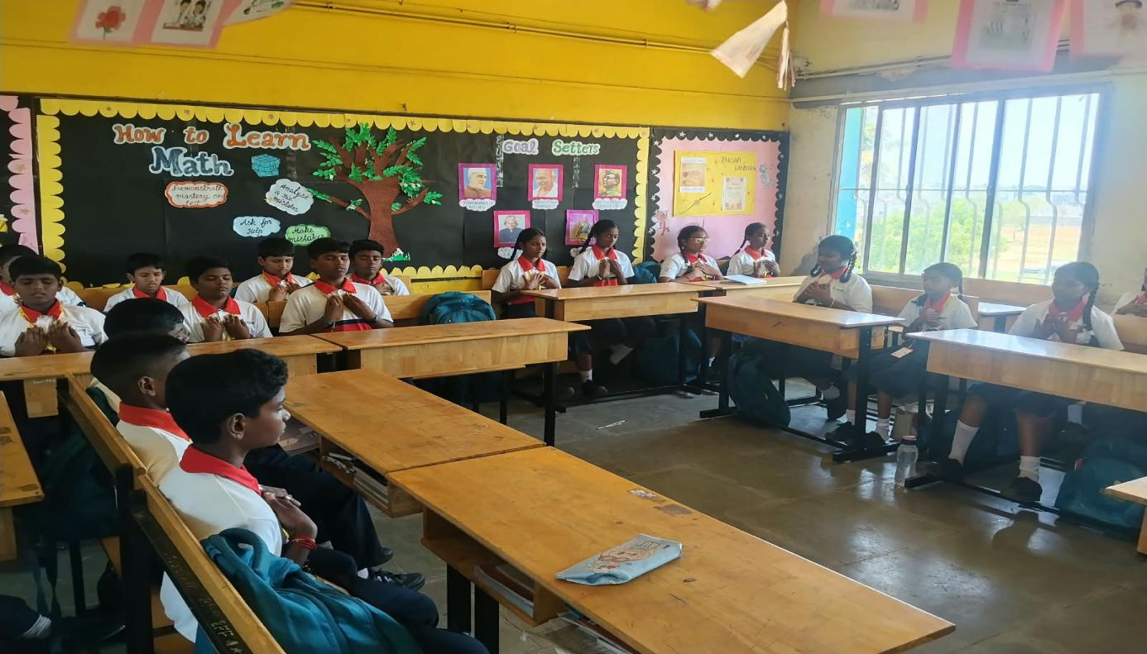

Leader in Me (7 Habits)

A character-building and leadership framework that helps students develops responsibility, teamwork, and personal effectiveness.
- Be Proactive
- Begin With the End in Mind
- Put First Things First
- Think Win-Win
- Seek First to Understand, Then to Be Understood
- Synergize
- Sharpen the Saw

Practice Examples:

  - Goal-setting journals
  - Weekly reflection on habits
  - Classroom leadership roles
  - Peer listening and empathy exercises
  - Group tasks emphasizing cooperation and “win-win” solutions

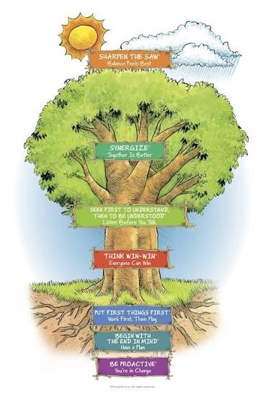
Benefits:

  - Builds self-discipline and responsibility
  - Improves communication and empathy
  - Enhances decision-making and emotional awareness
  - Encourages teamwork and leadership in everyday situations
Link: https://youtu.be/Yf170lyHdsM?si=GdnkZTSiOszj0CaL

Six Thinking Hats

A structured thinking tool to help students see problems from multiple perspectives and think more creatively and systematically.

The Six Hats

  - White Hat – Facts & information
  - Red Hat – Feelings & intuition
  - Black Hat – Caution & critical thinking
  - Yellow Hat – Optimism & benefits
  - Green Hat – Creativity & new ideas
  - Blue Hat – Planning & process control

Practice Examples:

  - Analyzing a story or real-life situation using all six hats
  - Group problem-solving sessions where each student "wears" a hat
  - Decision-making exercises
  - Creative brainstorming using the Green Hat only

Benefits:

  - Enhances critical and creative thinking
  - Helps students consider multiple viewpoints
  - Improves problem-solving and reasoning
  - Builds structured thinking and better decision-making skills
Link: https://youtu.be/Yf170lyHdsM?si=GdnkZTSiOszj0CaL

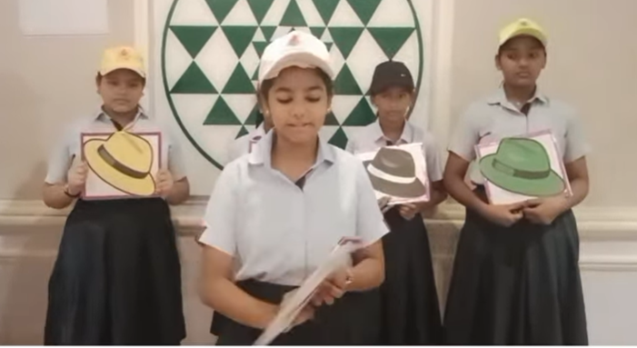

Bring Home Activity

Bring Home Activity is a home-based extension program designed to reinforce classroom learning, encourage parent–child interaction, and help students apply their skills in real-life situations.
Students receive a Bring Home Activity Kit (Grade 1 to 8), which contains two sets of materials. Along with the kit, activity links are uploaded for guidance. Students practice the tasks at home using the kit and then demonstrate and explain how they completed the activity.

Practice Examples:

STEM Kit Task & Creative Challenge: Using given materials (sticks, connectors, magnets), build a simple structure (bridge, tower, or shape) and record a short explanation video.

Benefits:

  - Strengthens parent–child bonding through shared, meaningful tasks.
  - Reinforces classroom concepts through hands-on, real-life practice.
  - Builds communication skills as students explain and demonstrate their work.
  - Encourages independent learning, responsibility, and confidence.
  - Provides an opportunity for students to apply creativity, problem-solving, and critical thinking beyond the classroom.
  - Helps teachers assess the child’s practical understanding in a home environment.

Link: https://youtu.be/rMRlMNP7lNg?si=9l1c4E9xTfZdvFtM
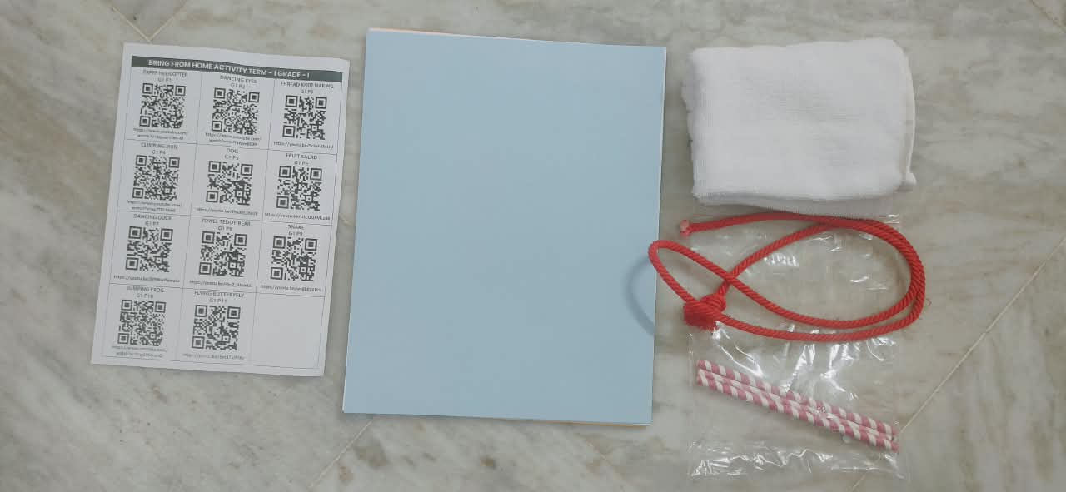

Yoga

Students learn basic yoga postures, breathing exercises, and relaxation techniques with correct body alignment.

Practice Examples:

Surya Namaskar, Breathing exercises like Pranayama, Simple asanas such as Tree Pose, Cobra Pose, and Butterfly Pose.

Benefits:

  - Improves flexibility, balance, and posture
  - Reduces stress and increases focus
  - Promotes emotional well-being and body awareness

Link: https://www.youtube.com/watch?v=T7x53oq4PrM&t=12s

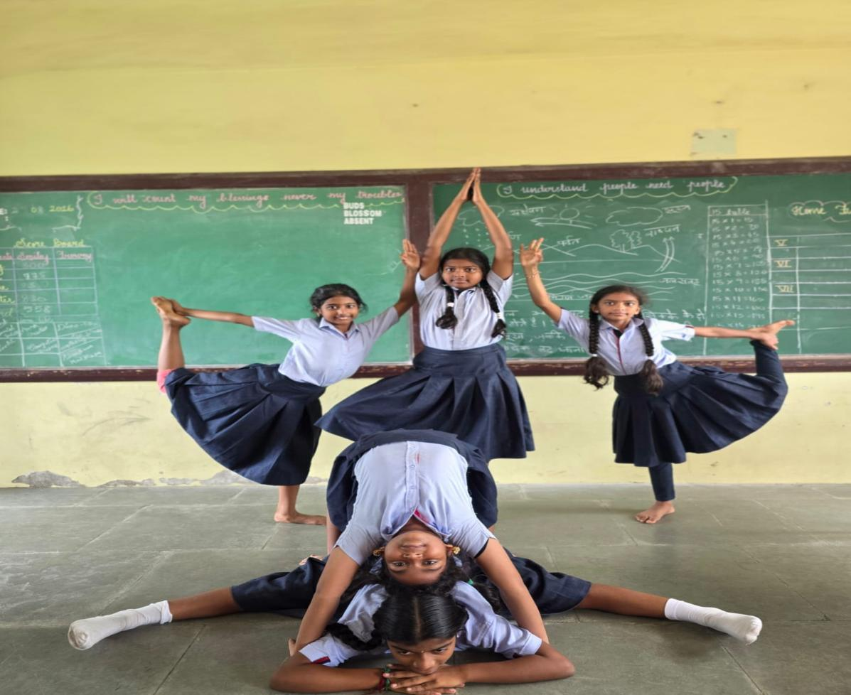

Silambam: (A traditional Indian martial art using a long bamboo stick)

Students practice basic footwork, hand movements, and safe handling of the staff.

Practice Examples:

Basic spins and strikes, Footwork drills, Partner practice with controlled movements.

Benefits:

  - Enhances coordination, reflexes, and strength
  - Builds confidence and discipline
  - Teaches self-defense skills
Link: https://youtu.be/yNJhcevoy58?si=lNj9hgmCOTAS8RZF
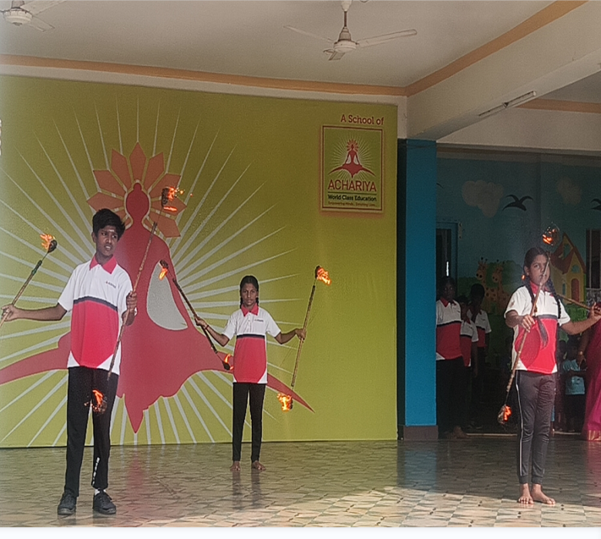
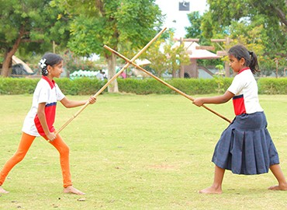




Malkhamb: (A traditional sport performed on a rope)

Students learn basic holds, climbing techniques, and simple balancing poses on the rope.

Practice Examples:

Basic pole mounting, simple sitting or standing positions and beginner balancing and stretching poses.

Benefits:

  - Strengthens core muscles and improves flexibility
  - Builds endurance and body control
  - Boosts focus, confidence, and mental resilience
Link: https://youtu.be/JmsU8wbSXhc?si=paGvTQY2K_qd-2zb

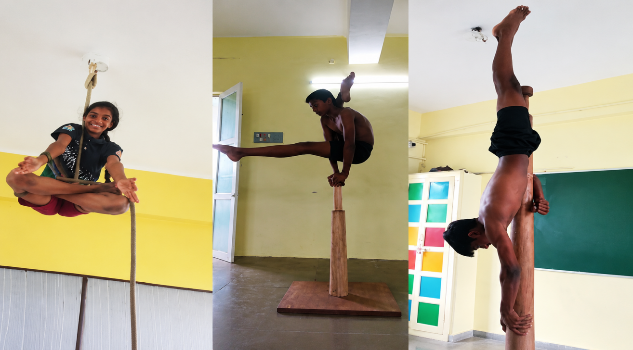

Happy Handwriting (Achariyan Font)

Achariya Font is a specially designed handwriting style used in our school to help children learn neat, legible, and uniform writing. It guides students to write correctly using:

  - Four-line writing
  - Two-line writing
  - Basic strokes and patterns
  - Correct letter formation
  - Proper spacing and alignment

Happy handwriting means setting clear standards for how each letter, word, and sentence should look when written correctly. It provides a reference model for teachers and students so everyone follows the same format.

Practice Examples:

    - To maintain uniformity in handwriting across all classes
    - To ensure students follow the correct letter formation using Achariya Font
    - To help teachers track the progress and identify areas needing improvement
    - To ensure children gradually move from four-line writing → two-line writing → single-line writing

Benefits:

    - Develops Uniform & Neat Writing
    - Enhances Reading & Spelling
    - Boosts Academic Confidence
    - Supports Slow Learners
    - Reduces Teacher Correction Load
    - Builds Lifelong Writing Habits

Link: https://www.youtube.com/watch?v=DBgh-z-FWOM

40. Math Lab Learning

Math Lab Learning is an activity-based instructional approach where students learn mathematical concepts through hands-on activities, concrete materials, models, experiments, and real-life applications. It helps students understand abstract mathematical ideas by exploring, observing, measuring, reasoning, and discovering concepts themselves.

Practice Example:

For a lesson on Fractions, students use fraction strips, fraction circles, or paper folding to represent different fractions. They compare the fractions, identify equivalent fractions, and verify their observations through practical activities.
Benefit:

Encourages conceptual understanding, active participation, problem-solving, and mathematical thinking.

- Students learn mathematical concepts through hands-on experience
- Classroom becomes more interactive and engaging
- Students develop logical reasoning and problem-solving skills
- Abstract concepts become easier to understand through concrete materials
- Students get opportunities for exploration, observation, and discovery

Link: https://youtu.be/I8hT0NgnxuM?si=t-cXbOb7Nf-fWh6I
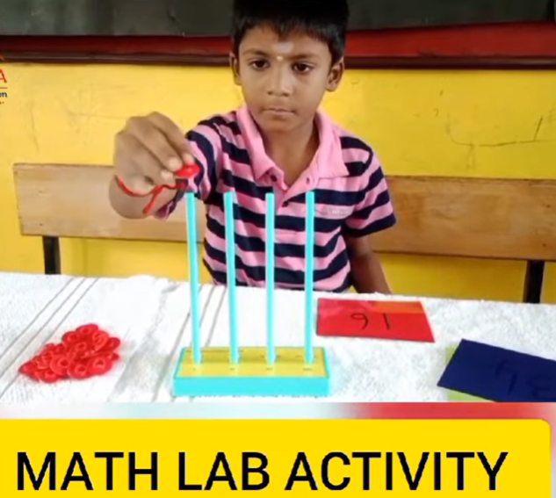

41. Chess
Chess Activity Learning is an activity-based instructional approach where students learn through playing chess, solving chess puzzles, practicing moves, and applying logical strategies. It helps students develop concentration, critical thinking, decision-making, and problem-solving skills through practical gameplay and real-life situations.

Practice Example:

For a chess lesson on Chess Pieces and Their Movements, students use a chessboard and pieces to practice how the King, Queen, Rook, Bishop, Knight, and Pawn move. They identify possible moves, capture pieces, solve simple chess puzzles, and play short games to apply the rules they have learned.

Benefit:

Encourages concentration, logical thinking, strategic planning, decision-making, and problem-solving skills.

- Students learn chess concepts through hands-on gameplay
- Classroom becomes more interactive and engaging
- Students develop concentration, patience, and logical reasoning
- Students improve decision-making and problem-solving skills
- Students get opportunities for strategic thinking, exploration, and practice

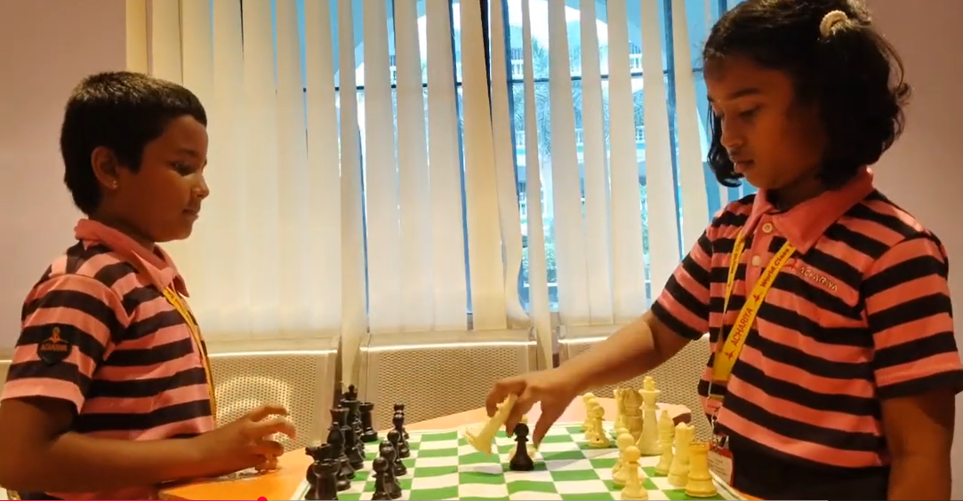
Link: https://youtu.be/7LgJb-khKQc?si=KpHeuufBkIXDk0cN

42.Drawing Activity
Drawing Activity Learning is an activity-based instructional approach where students learn through sketching, colouring, designing, observing, and creating pictures. It helps students express their ideas, develop creativity, improve observation skills, and understand concepts through visual representation.
Practice Example:

For a lesson on Shapes and Patterns, students draw different geometric shapes such as circles, squares, triangles, and rectangles. They combine these shapes to create pictures, patterns, or simple designs and colour them creatively.

Benefit:

Encourages creativity, imagination, observation, self-expression, and visual thinking.

- Students learn concepts through drawing and creative activities
- Classroom becomes more interactive and enjoyable
- Students develop creativity and imagination
- Students improve their observation and fine motor skills
- Students get opportunities for self-expression, exploration, and artistic practice

Link: https://youtu.be/cERgZd2nMpk

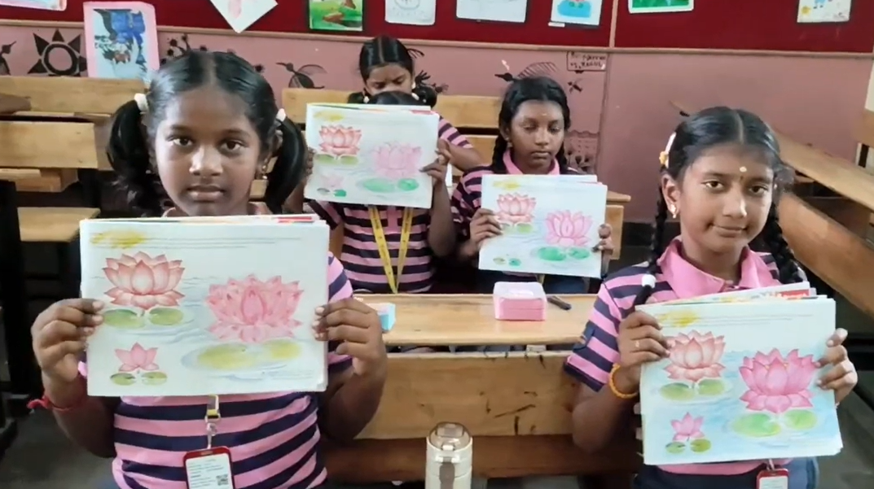

43. Dining Lounge Act
Dining Lounge Activity is based approach where students learn through practical experiences related to dining, table manners, food habits, communication, and social interaction. It helps students develop good eating habits, proper etiquette, communication skills, and a sense of responsibility in a real-life setting.
Practice Example:

For a lesson on Table Manners and Dining Etiquette, students practice arranging a dining table, using plates, spoons, forks, and glasses correctly, following proper eating manners, and communicating politely with others during a meal.

Benefit:

Encourages good manners, social skills, communication, confidence, and responsible behaviour.

- Students learn dining etiquette through practical experience
- Students develop good table manners and eating habits
- Students improve communication and social interaction skills
- Students learn to be responsible and independent during meals
- Students get opportunities to practice cooperation, sharing, and polite behaviour

Link: https://www.instagram.com/reel/DazTVUdzMYr/?igsh=MXN1NG0zOXd1enY5cg==

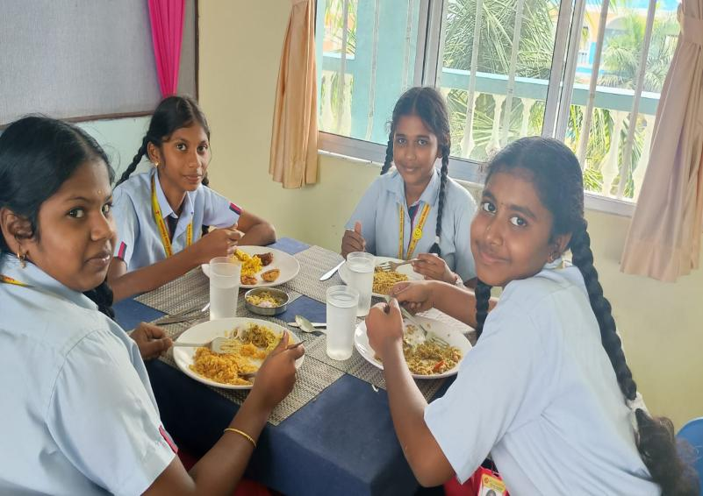
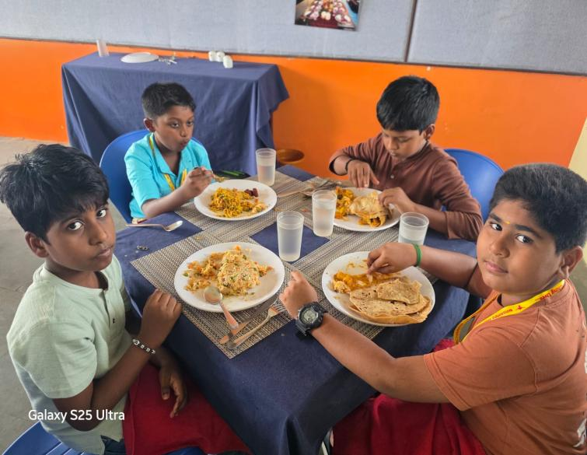

44. Jeeva Raksha
Jeeva Raksh a Activity Learning is a practical learning approach where students learn basic life-saving skills, first aid, emergency response, and safety measures through demonstrations and hands-on activities. It helps students understand how to respond calmly and responsibly during emergencies.
Practice Example:

For a lesson on Basic First Aid, students learn how to respond to minor injuries such as cuts, burns, or sprains. They practice using a first-aid kit, applying a bandage, and learning the correct steps to follow while seeking help during an emergency.

Benefit:

Encourages safety awareness, confidence, responsibility, quick thinking, and helpfulness.

- Students learn basic life-saving and first-aid skills through practical activities
- Students become aware of safety and emergency procedures
- Students develop confidence and the ability to remain calm during emergencies
- Students learn to help others responsibly
- Students get opportunities to practice teamwork, decision-making, and problem-solving skills

Link: https://www.youtube.com/shorts/nsM95eGgTPo?feature=share

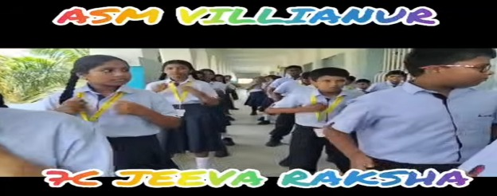

Impact of Benchmarking Practices

Category | Practices | Key Outcomes
Academic Excellence | Flip Learning, Spiral Learning, ASTRA (Olympiads). | Improved academic results, curiosity-driven learning
Cognitive Growth | Parallel Processing, Ambidexterity, Study Techniques | Higher-order thinking, analytical ability, creativity
Emotional Well-being | Meditation, Nap Time, WOW Schooling, Spiritual learners, Yoga | Mindful, emotionally balanced learners
Character Building | Parihara Statement, Habitometer, Yellow, White Book & Green Book | Responsible, reflective, self-aware individuals
Skill Development | Skill Project, Theme Project, 21st Century Skills, Leader in Me, Six Thinking Hats | Innovative, collaborative, and problem-solving learners

The benchmarking practices serve as a roadmap for continuous quality enhancement in academic, emotional, and behavioral dimensions. Through structured reflection, innovation, and collaboration, the school fosters a community of learners equipped with competence, character, and compassion.

For Reference Visit Our Link: www.youtube.com/@achariya.villianur

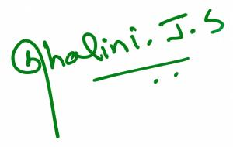

PRINCIPAL

